Lecture 14, October 7, 2010 (Key Points)

14. Transformation of Rainfall to River flows

A hydrograph is a plot of stream discharge (m³/s) versus time during and after a rainfall or a snowmelt event. USGS website http://water.usgs.gov/waterwatch/ can be used to see hydrograph variability throughout the US. Locate Boulder creek at the 75th and Iowa river at Marshalltown as examples. Hydrograph analysis and prediction have direct applications in engineering design and in decision-making.

14.1 Streamflow Generation Mechanisms
Runoff generation in response to precipitation takes place over hillslopes adjacent to channel links of a river network in a basin, as shown in Figure 14.1 (Same as Fig. 9.1, Lecture 9). The spatial scale of hillslopes is ~10² m. Stream discharge hydrograph consists of different combinations and percentages of these physical processes: (i) Infiltration excess overland flow, (ii) Saturation excess overland flow, (iii) Subsurface storm flow from soils below the surface of hillslopes. Brutsaert (2005, Ch. 11) gives an excellent discussion of the mechanisms, and the physical complexity that is associated with each one. We briefly describe them following Brutsaert (2005).
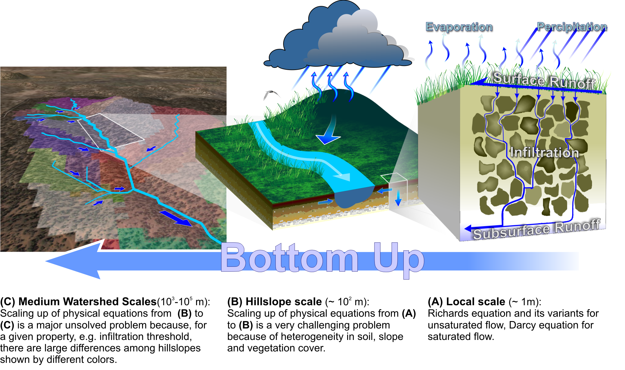
Figure 14.1. A schematic illustration of major challenges in scaling–up physical equations from the local scale to medium watershed scales

- Infiltration excess overland flow:
This type of flow occurs when the rainfall rate is larger than the infiltration capacity, so that there is an excess rainfall, which runs off over the surface (Fig. 14.2). Although

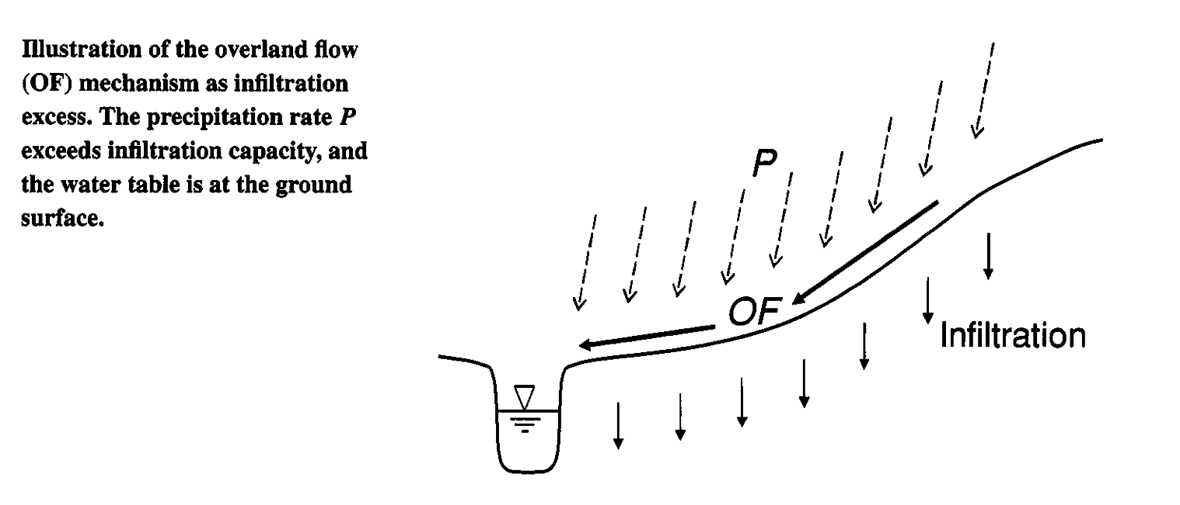
Figure 14.2 A schematic of infiltration excess overland flow (Brutsaert, 2005, Fig. 11.2)

this flow generation concept is sometimes associated with the name of Horton, it goes back much earlier. In these and other early studies concerned with maximal rates of runoff in problems of flooding and erosion, it was assumed that the infiltration rate is smaller than the precipitation rate over the entire catchment. In the rational method, the infiltration is taken as a fraction of the precipitation, whereas in the unit hydrograph approach and in Horton’s work, the infiltration capacity or a related index is subtracted from the precipitation. Thus it was assumed that the infiltrated water is “lost” and that virtually all stormflow results from the overland flow of the precipitation excess (Figure 14.2). In the prediction of extreme flows for design purposes in disaster situations, this assumption of overland flow was not unreasonable.
It is now understood that overland flow is not a universally occurring phenomenon,
that in many situations it may not occur at all, and that its prevalence depends on the
nature of the catchment and of the intensity of the precipitation. But it can be expected
to be the main mechanism in catchments with relatively impermeable surfaces, and with
only a thin soil layer; such surfaces cover mostly urban environments, factory and farm
yards and other trampled soil areas, and rocky and stony areas with little or no soil or
vegetation, as seen in arid and desert environments. Thus it occurs most frequently in
areas where people live and work and in denuded arid regions. It can also occur on other more permeable surfaces, provided the rainfall is sufficiently intense.

- Saturation excess overland flow:
This type of surface runoff occurs over land surfaces that are saturated by emerging subsurface outflow from below and perched water tables, regardless of the intensity of the rainfall (or snowmelt) (Figure 14.3). It is a rapid and almost immediate transport mechanism to the stream channel, for the seepage outflow water and for the rainwater falling (or snow melting) on such areas. It usually takes place in conjunction with subsurface flow to the channel, but the relative magnitudes of surface and subsurface flows into the channel depend largely on the nature of the catchment and the precipitation. It is most often observed over limited areas in the immediate vicinity of the river channel where down slope subsurface flows emerge, and in wetlands, where
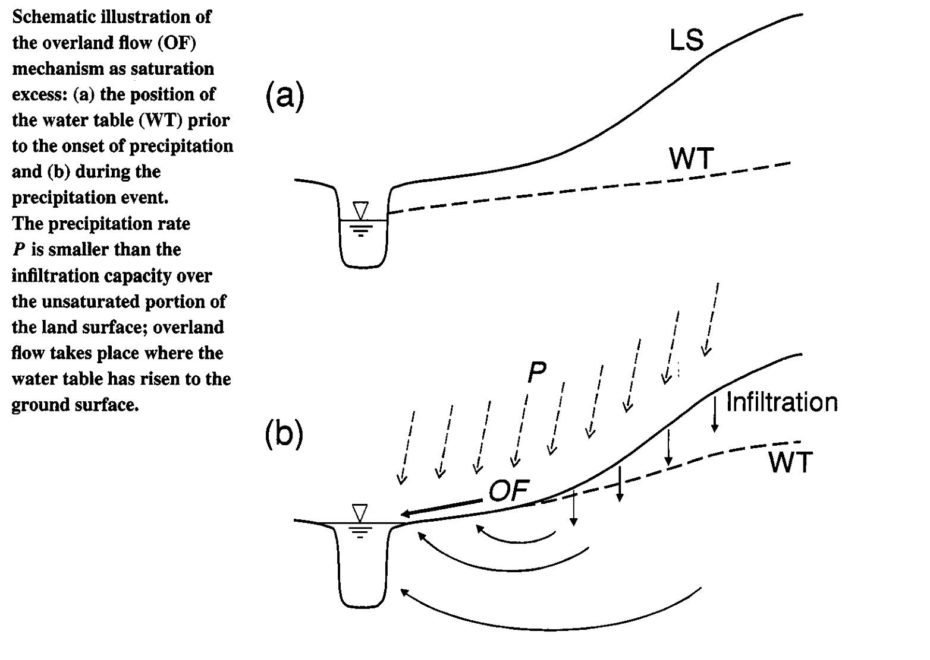
Fig. 14.3 A schematic of saturation excess overland flow (Brutsaert, 2005, Fig. 11.3)

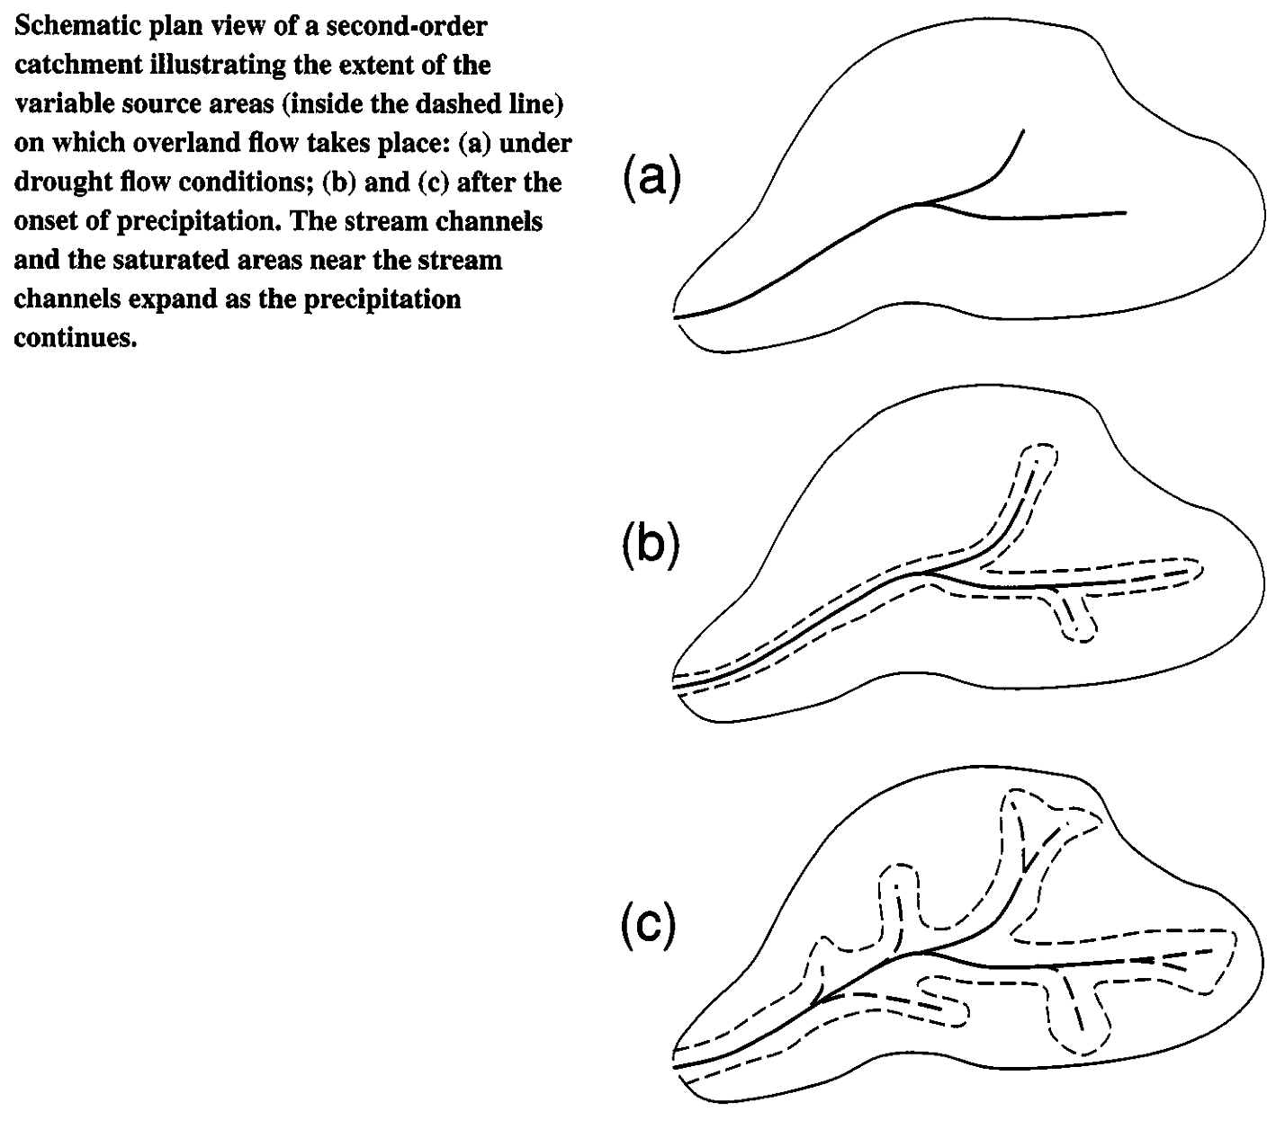
Fig. 14.4 A schematic of variable source areas (Brutsaert, 2005, Fig. 11.4)

the water table can rise rapidly to the surface; but it can also occur higher up in slope hollows, where elevation contours display strong curvature, thus forcing convergence of
the flow paths. Outside of these saturated areas the precipitation and other input can generally enter the soil surface
As early as 1961, US Forest Service hydrologists reported that in forested hilly catchments in the Coweeta section in the southern Appalachians of North Carolina, the streamflow hydrograph rises as a result of precipitation on the channel itself and as a result of the expansion of these saturated areas in its immediate vicinity. The expanding and shrinking areas are often referred to as variable source areas (Figure 14.4). On the basis of hill slope measurements in Vermont, Dunne and Black in 1970 also concluded that the storm flow originated from surface flow on limited areas along the stream channel. However, their interpretation of the mechanism was that this surface runoff was not fed significantly by subsurface outflow, but resulted mostly from rainfall on the expanding streamside areas; the role of the subsurface flow was mainly to control the expansion and subsequent contraction of the source areas. But saturation excess overland flow does not always occur in the immediate vicinity of the stream. In a tropical rainforest in northeast Queensland, high intensity rainfalls was observed to generate widespread perched water table conditions close to the soil surface, which emerge easily. This results in saturation excess overland flow accompanied by subsurface flow within the top 20 cm.

(iii) Subsurface storm flow
In many catchments under natural conditions infiltration is never exceeded, and the precipitation and other input can readily enter into the ground surface; thus the subsequent flow to the stream channel takes place below the surface, presumably through the soil mantle of the catchment. It was confirmed in several experimental investigations that subsurface flow can even be the only mechanism under certain conditions. Many resisted this concept on the grounds that porous media flow is much

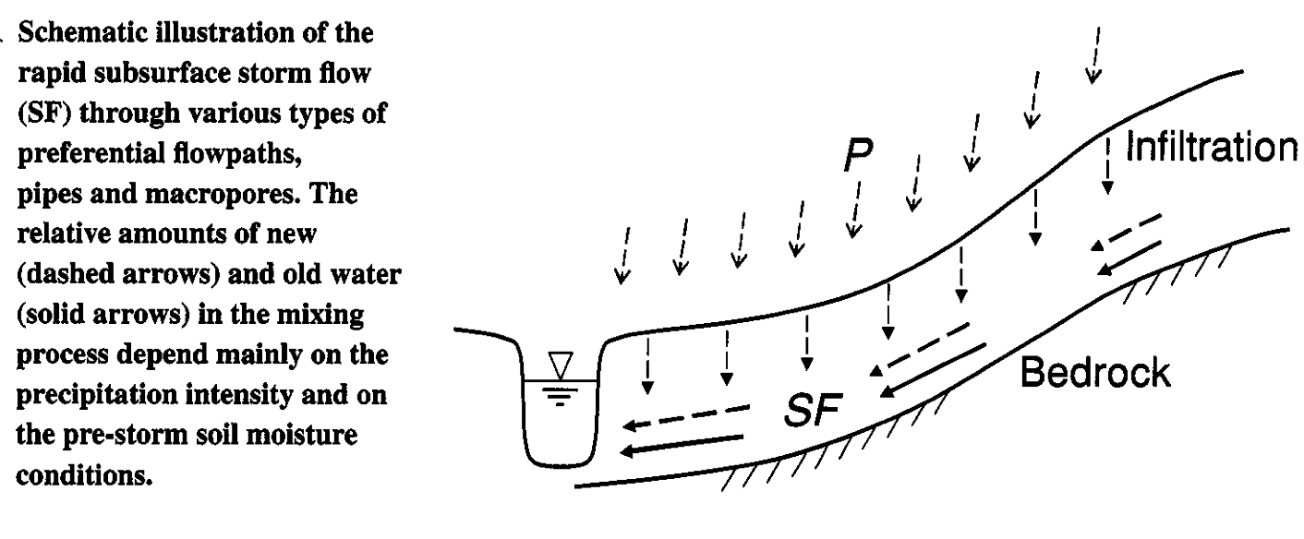

Fig. 14.5 A schematic of subsurface storm flow (Brutsaert, 2005, Fig. 11.11)

too slow compared with overland flow to be able to produce the observed streamflows. One early explanation of this paradox came from Hursh in 1944, who assumed that the transport takes place through secondary porosity of particle aggregates, forming a three-dimensional lattice pattern, and through hydraulic pathways consisting of dead root channels and animal burrows. At the time, this possibility of macropore flow and piping seems to have been largely dismissed as unrealistic by experimentalists and mostly ignored by modelers. However, subsequent experimental work in the field, some of it with chemical and isotopic tracers, has produced ample and incontrovertible evidence not only for macropore flow and its importance, but for several other mechanisms enhancing subsurface flow as well. We refer to Brutsaert (2005, Ch. 11) where complexity of these mechanisms is explained in great detail.

Summary of runoff generation mechanisms
In order to keep the formulation sufficiently simple and parsimonious, it may be necessary to identify and include only the dominant mechanisms for any given set of conditions, and to accept some inevitable uncertainty resulting from the omission of the remaining minor mechanisms. On the basis of a knowledge of these local conditions, the analyst must then decide which mechanisms are the major ones that must be considered to represent a particular catchment. For instance, different kinds of subsurface flow can be assumed to dominate the runoff process in humid areas with an active vegetation. Well-developed mineral soils undoubtedly favor the development of preferential flow paths, whereas thin porous soils with organic litter probably lead to shallow lateral flow of the perched water above the less permeable soil or bedrock. Wetland areas near the stream may allow rapid mobilization or ridging of the water table, and the development of partial and variable source areas, on which saturation excess overland flow can take place. Infiltration excess overland flow will be prevalent during large precipitation events on non-vegetated surfaces in arid regions and in areas subject to intense human activities.

14.2 Lumped versus Spatially Distributed Formulations

Scale is the appropriate criterion to classify the different methodologies. Accordingly, one can distinguish two general classes of models that have been used in the past to simulate streamflow generation. In the distributed models, also called runoff routing models, the computational scales are much smaller than the flow domain characterizing the catchment, whereas in the lumped models, such as the unit hydrographs, the computational scale is essentially of the same order as that of the catchment.
The main feature of the distributed approach is that the basin outflow is obtained by tracking the water through its different transport phases in the basin interior. In brief, these phases are surface and subsurface transport into the stream channel network, in response to precipitation after it reaches the ground surface, and the subsequent open channel flow to the basin outlet; between precipitation episodes the basin outflow is dominated by baseflow and evaporation processes. The different mechanisms in each of these transport phases may be described by combining some of the formulations of the relevant processes. These formulations invariably involve a number of assumptions neglecting certain aspects of the flow, which are considered to be less important; this means that they can be only simplified representations of reality. The distributed approach has been receiving increasing acceptance in recent years with the advent of digital computation and with the growing availability of higher-resolution data from digital terrain and other geographical information systems; rapid advances continue to be reported in the literature.
In contrast, the lumped models, whose computational scales are of the same order of magnitude as the catchment scales, rely on fewer parameters, which are generally easier to estimate from the available data. Therefore, they are easier to apply in basin outlet flow simulations for prediction and forecasting purposes. Unfortunately, as the computational scale increases, it becomes increasingly difficult to give a physical interpretation to these parameters, in the sense of the processes described in Chapters 2-10. This means that it is usually impossible to predict changes in these parameters, as the catchment undergoes physical changes, such as those resulting from an evolving land use or changing climate. Another drawback is that even when the catchment characteristics remain unchanged, catchment-scale parameters are incapable of accommodating spatial variability of the input (e.g. rainfall) and of the flow processes (e.g. infiltration and evaporation). Moreover, it is impossible to use this approach to describe the detailed flow paths required in the prediction of pollutant transport or erosion. In spite of all these shortcomings, the lumped approach continues to be useful in the prediction of streamflow for certain operational and design purposes.
In closing, it should be understood that, although a classification into distributed and lumped models is useful to bring some order in the multitude of possible approaches, it is also somewhat artificial. However, the level of model complexity necessary for a specific application is still not well known; nor is it clear what scenarios warrant the use of more complex models or under what conditions a distributed model will consistently outperform lumped models. In other words, there is still no general consensus regarding the optimal simplifying assumptions that are most appropriate to describe streamflow generation under a given set of conditions. Although it could be argued that there never will be a consensus, this field is in an active state of development and rapid advances continue to be made.

14.3 Towards a Unification of distributed and Lumped Approaches
Since the mid 1990s, progress has been made to understand a lumped (unit hydrograph) approach in terms of a spatially distributed approach. The formulation is very general and can include diverse needs ranging from flood prediction and solute transport in river basins to land-atmosphere interactions. Multiscale variability of a river network in a landscape plays a foundational role in quantifying multi-scale dynamics of rainfall to runoff transformation. This modern, multi-scale dynamical approach is an active research area. Nevertheless, some key elements can be introduced in an introductory graduate course, which is our key objective.

References

Brutsaert, W. Hydrology: An introduction, Cambridge, 2005.

